How Much Water Can Sunny The Saguaro Drink?
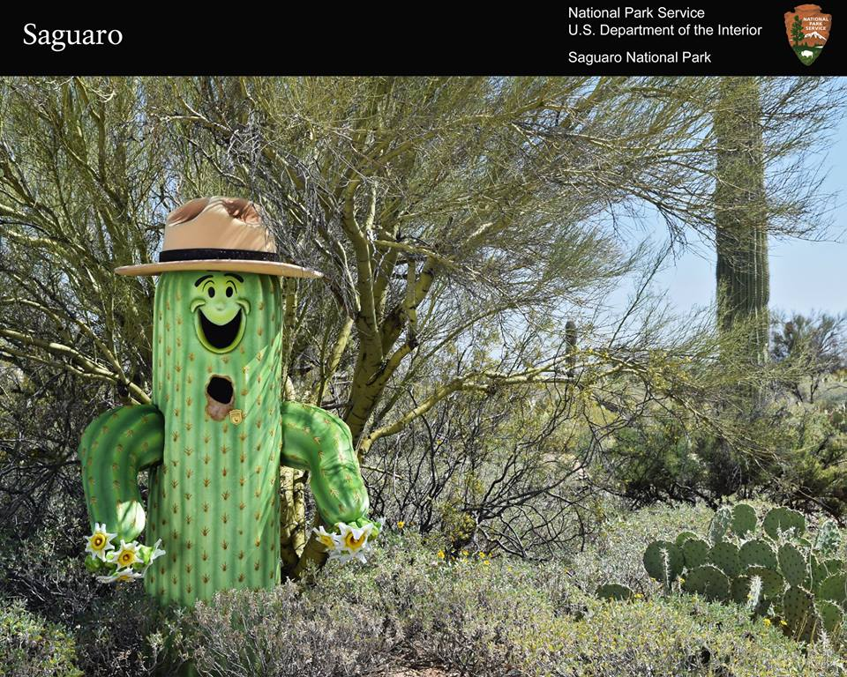
Sunny the Saguaro under a nursing tree
NPS Photo

Rumors have it that Sunny the Saguaro is a one tall cactus! But who knows what his actual height might be? Desert animals speculate that he might be between 6 to 40 feet tall! However, the park rangers are more curious about how much water Sunny can drink to fill himself up.
As far as Sunny can remember he was 3 inches tall when he was 10 years old, 3 feet tall when he was 25 years old, and 16 feet tall when he was 60 years old! Now, sunny is 20 feet tall and still growing!
Can you estimate how old Sunny the Saguaro is based on his height? Using his height, can you estimate how much water it will take to fill Sunny? Sunny is 20 feet tall and 18 inches wide. Assume that Sunny is 100% water inside.

